An AI-Driven Framework for Automated Extraction of Glass Dissolution Data from Scientific Literature

Abdelhak Ouanzougui [0009-0001-8249-5187], Caroline Chabal [0000-0002-6958-2542] , Stéphane Gin [0000-0002-1950-9195] , Pierre Frugier [0009-0005-3892-027X], François Le Fèvre [0009-0003-1221-7127]
CEA, DES, ISEC, DPME, Univ Montpellier, Marcoule, France

Abstract
Assessing the early-stage dissolution rates of nuclear waste glasses is key to evaluating their safety over time. However, progress in this area is often slowed down by the lack of well-organized, high-quality experimental data. To tackle this challenge, we created an AI-based system to automatically gather, normalize, and organize glass dissolution data from research articles, with a focus on initial dissolution rate. Our approach, built using the open-source platform Langflow and powered by the Mistral-small-22B language model, combines modular AI "Brain" units, carefully designed prompts, and rule-based checks. From a selection of articles, we extracted 735 unique glass-test cases, each with up to 107 different parameters. We then built custom neural networks to successfully correlate dissolution rates to glass composition. Beyond nuclear glass corrosion, this approach could help speed up data collection and predictive modeling in other complex material systems.
Introduction
A major challenge in materials science and environmental protection is ensuring the safe, long-term storage of high-level radioactive waste. Borosilicate glasses are widely regarded as the optimal material for immobilizing radionuclides, thanks to their robust chemical stability, flexibility, and demonstrated reliability under conditions relevant to waste repositories [1,2]. A key determinant of their effectiveness is the initial dissolution rate, also called forward rate, which indicates how rapidly the glass degrades when exposed to water, far from saturation. This dissolution rate mainly depends on glass composition, temperature and pH. Precisely determining this rate is crucial for predicting long-term glass behavior, enhancing safety assessments, and ensuring the integrity of waste storage sites over thousands of years [3,4]. In this paper, we denote this rate as r₀.
Despite extensive studies and many data in the literature, a significant obstacle persists in predicting the initial dissolution rate : the absence of uniform, readily available data. Essential information—such as glass compositions, dissolution rates, and experimental conditions—is often scattered across figures, tables, and supplementary materials, reported in inconsistent formats and units [5,6]. This disorganization, combined with the absence of a centralized database, prevents the systematic use of literature data to improve existing or develop new models.
Recent advancements in artificial intelligence and materials informatics provide a promising path forward. Large language models (LLMs) can now process unstructured scientific texts, extract meaningful patterns, and standardize diverse datasets [7,8]. While AI has already proven effective in fields like catalysis and polymer science [9,10], its application to nuclear glass dissolution has been largely unexplored—until now.
In this study, we developed an AI-driven framework to automate the construction of a comprehensive database on glass corrosion, focusing on initial dissolution rates across a broad range of compositions and experimental conditions. Built on the open-source Langflow platform and powered by the Mistral-small-22B LLM, our system integrates advanced prompt engineering, rule-based validation, optical character recognition (OCR), and Python-based data normalization to process scientific documents. From an initial collection of over 50 publications, we selected 20 that met stringent criteria, resulting in 735 unique glass-test cases, each described by up to 107 parameters. The full set of articles is available in GitHub repository [19], and the parameters are detailed in the Methods section.

Using this dataset, we trained neural networks to predict the glass dissolution rates based on boron or silicon release in solution, achieving high accuracy (R² = 0.971 for boron and R² = 0.914 for silicon). Beyond advancing our understanding of nuclear glass, this work introduces a flexible, adaptable strategy for overcoming data deficiencies in materials research. By doing so, it accelerates the development of precise, data-driven models—even in fields where comprehensive datasets are hard to come by.
Results and Discussion
3.1 Performance of the Automated Data Extraction Framework
The pipeline successfully filtered and organized data from scientific literature, but it also exposed a major issue: there simply aren’t enough high-quality, complete datasets out there. We started with over 50 research papers, but only 20 made the cut—meaning less than a third (~32%) were actually usable. This low success rate underscores a persistent problem in glass corrosion research: critical information, like standardized compositions or unique definition of the selected parameter, is often missing, inconsistent, or poorly documented [5, 6]. This holds true despite the decision to initiate this study with the initial rate, a widely recognized reference parameter for glass alteration.
That said, the data we did extract was highly reliable. The system accurately distinguished between similar glass types (for example, telling NSAC19 apart from NSAC21) and pulled compositional data from tables or text with 100% accuracy, as confirmed by expert review. (The dataset and original articles are available on GitHub [19], as mentioned in the introduction, allowing anyone to verify the extracted data). By standardizing all compositions into molecular percentages (mol%), we established a consistent basis for comparing results across different studies. This also enabled us to link the data to key chemical indicators—such as boron-to-silicon (B/Si) and sodium-to-silicon (Na/Si) ratios measured in solution—which are critical for predicting how glass degrades over time. [1, 3].
The process also had to adapt to a wide range of document qualities and formats. Most modern PDFs were processed without issues, but older or scanned reports required optical character recognition (OCR). Basic layouts worked fine with open-source OCR tools, but complex tables needed high-precision scanning to avoid errors—a challenge that matches what others have reported about OCR depending heavily on document quality [10]. By tailoring the processing to each document type, we managed to include valuable data that might otherwise have been excluded.
In the end, we compiled a unified database of 735 unique glass-test cases, covering 107 different parameters from the 20 selected papers. As a result, we’ve put together one of the most comprehensive and well-organized datasets on borosilicate glass dissolution available from scientific literature. But before it could be used to build models, it needed to cleaned up—removing empty or irrelevant columns (like those filled with zeros or missing data) and streamlining the parameters. After this process, we ended up with two refined datasets: one focused on glass dissolution rates measured via boron release (covering 370 test cases and 38 parameters) and another focused on silicon (with 230 test cases and 38 parameters). These refined datasets became the foundation for training machine learning models to predict initial dissolution rates.
3.2 Neural Network Modeling Performance
Using the two refined datasets from Section 3.1—370 boron test cases and 230 silicon test cases, each with 38 parameters—we trained separate neural networks to predict the initial dissolution rate (Ln(r₀)) based on glass composition (in mol%), temperature, and pH.
For boron, the model performed exceptionally well, achieving an R² of 0.971, with a root mean square error (RMSE) of 0.450 and a mean absolute error (MAE) of 0.342 (see Figure 1a). A MAE of 0.342 on ln(r₀) means that, on average, the predicted ln(r₀) values deviate by ±0.342 from the true values, which roughly corresponds to predictions of r₀ ranging from 71% to 141% of the actual values. This level of error is comparable to the experimental uncertainty typically associated with dissolution rate measurements: Fournier et al. [20] reported that experimental r₀ values (equivalent to V₀) are generally accurate within ±30%, i.e., between 70% and 130% of the true value. In logarithmic space, this corresponds to approximately ±0.26 on ln(r₀), since ln(1.3) ≈ 0.26 (here the upper bound ln(1.3) is used rather than ln(0.7), to avoid overestimating the error). Thus, the model error is of the same order of magnitude as the experimental uncertainty.
The predictions lined up almost perfectly with experimental results, with only a few outliers. The residuals were evenly spread around zero (Figure 1b), and the training and validation loss curves leveled off smoothly (Figure 1c), suggesting the model generalizes well without overfitting.

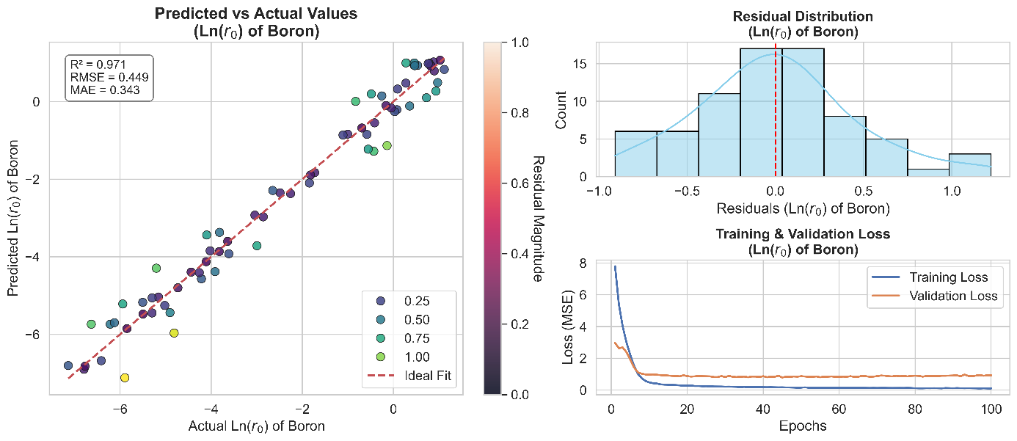

Figure 1: Performance of the neural network model for boron initial dissolution rates. (a) Predicted vs. actual Ln(r₀) of boron; (b) distribution of residuals; (c) training and validation loss curves.

For silicon, the model still did well, though not quite as strongly (R² = 0.914, RMSE = 0.694, MAE = 0.488; Figure 2a). It captured the overall patterns, but the residuals showed greater variability (Figure 2b). This MAE on ln(r₀) corresponds to predictions of r₀ ranging approximately from 61% to 164% of the true values, which remains of the same order of magnitude as the experimental uncertainty reported by Fournier et al. [20]. The somewhat higher error likely reflects the smaller dataset and the fact that other influencing factors—such as solution saturation, gel layer formation, or secondary phase precipitation—were not fully captured. This aligns with previous findings that silicon release is more sensitive to environmental conditions, whereas boron tends to be a more consistent indicator of early-stage dissolution [11,12].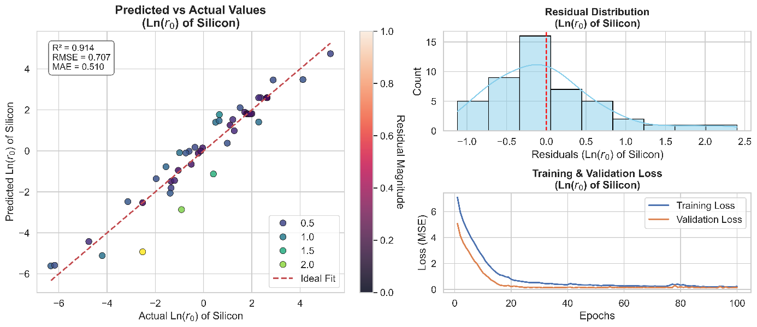

Figure 2: Performance of the neural network model for silicon initial dissolution rates. (a) Predicted vs. actual Ln(r₀) of silicon; (b) distribution of residuals; (c) training and validation loss curves.

The boron model’s effectiveness seems closely tied to the nature of its dataset. For boron, the majority of dissolution rates clustered below 4, with just a handful of exceptions near 7. In contrast, the silicon dataset initially contained values reaching into the hundreds or even thousands. Although we limited the silicon data to values under 20 (with a maximum around 10), its distribution stayed wider and less consistent compared to boron. This broader range, paired with a smaller sample size, may explain why the silicon model’s predictions were less accurate. When we included those extreme values, the model’s performance (see figure 3) dropped sharply (R² = 0.463, RMSE = 1.629, MAE = 0.883). This confirmed that removing them helped the model generalize better and kept the results more stable.
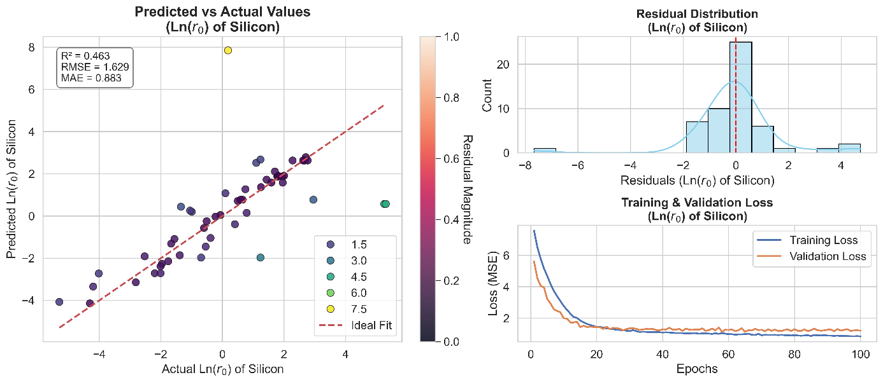
Figure 3: Performance of the neural network model for silicon initial dissolution rates with the extreme values included. (a) Predicted vs. actual Ln(r₀) of silicon; (b) distribution of residuals; (c) training and validation loss curves.

To test how well the model holds up, we looked at experiments where boron and silicon dissolved at almost the same rate—meaning their rates were very close, considering possible experimental errors. This group included 114 experiments. Since the dataset was small, we used a 5-fold cross-validation method to make sure the results weren’t just luck from one random split. This way, we trained and tested the model on different parts of the data, giving us a more reliable idea of how well it generalizes.
The model’s performance was solid: it scored an average R² of 0.824 , an RMSE of 1.099, and an MAE of 0.840 (±0.26) (see Figure 4). While the R² is a bit lower than when using the full dataset, the predictions are still strong and consistent. This shows the model can still pick up on the key patterns, even with stricter conditions. The training and validation errors both dropped steadily and evenly, meaning the model learned well without overfitting. The slow but steady improvement also suggests that with more data, the model could get even better—so the real challenge here is having enough data, not the model’s ability to learn.
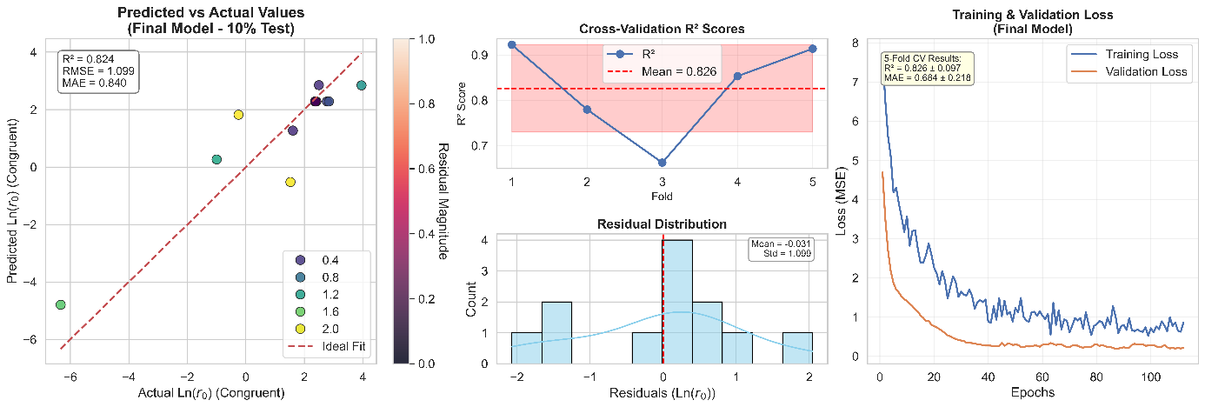
Figure 4: Performance of the neural network model for initial dissolution rates of congruent experiments using 5-fold cross validation. (a) Predicted vs. actual Ln(r₀) of silicon; (b) distribution of residuals; (c) training and validation loss curves.
To put these results in perspective, we also tested other models—Decision Trees, Random Forests, Support Vector Regression (SVR), and XGBoost—on the same datasets for boron and silicon (it doesn't include the dataset for congruency and for silicon with the extreme values) (Figures5–6). While SVR and XGBoost performed nearly as well, the neural network still came out on top, offering the best mix of accuracy and adaptability. In contrast, Decision Trees struggled more, often overfitting the data, probably due to the dataset's limited size, which reduced the reliability of their predictions. This matches broader trends in materials science, where neural networks often outperform traditional machine learning methods when dealing with complex, nonlinear relationships between composition, environment, and material behavior [13, 14].

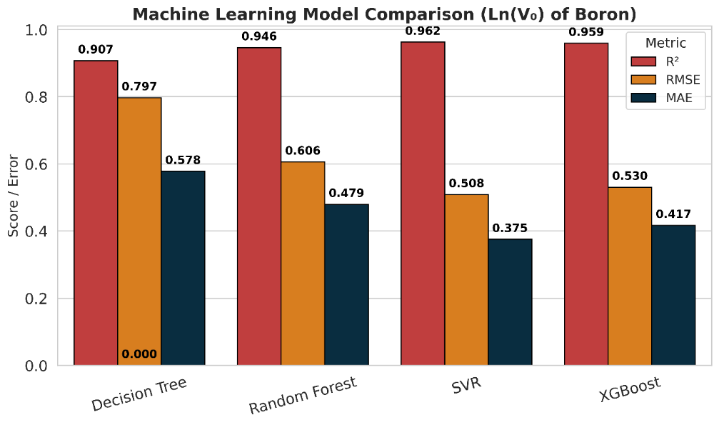
Figure 5: Comparison of machine learning models for boron initial dissolution rates. Performance of Decision Tree, Random Forest, SVR, XGBoost, and the neural network in terms of R² (Coefficient of Determination), RMSE (Root Mean Squared Error), and MAE (Mean Absolute Error).
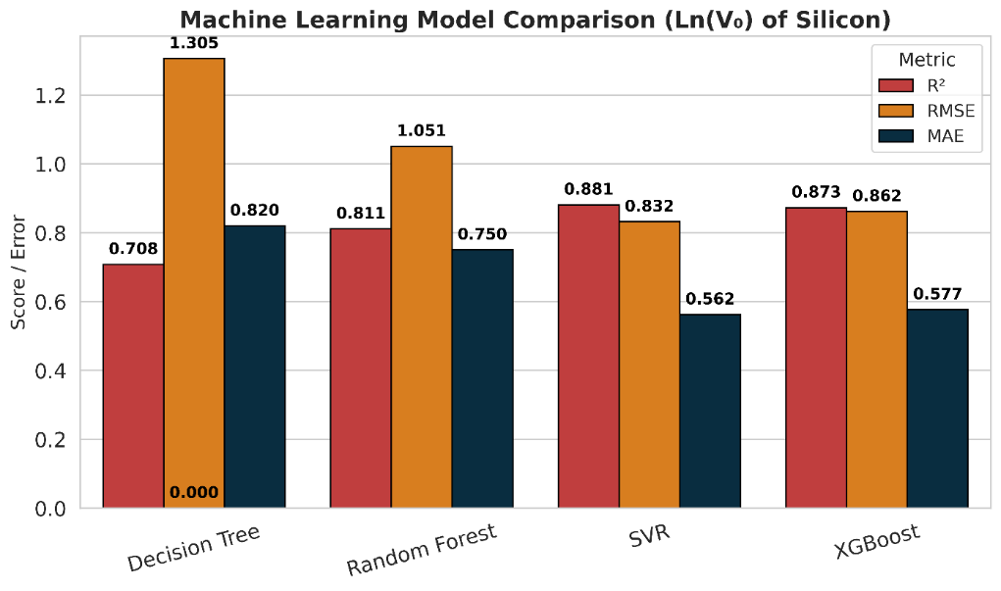
Figure 6: Comparison of machine learning models for silicon initial dissolution rates. Performance of Decision Tree, Random Forest, SVR, XGBoost, and the neural network in terms of R², RMSE, and MAE.

As concluding remarks, it can be said that by combining AI-powered data extraction, consistent standardization, and close attention to experimental details, it is possible to create a high-quality dataset that truly supports accurate and trustworthy predictive modeling. Even though the dataset wasn’t massive (370 boron cases and 230 silicon cases), the models still achieved strong performance (R² = 0.971 for boron, R² = 0.914 for silicon), consistently outperforming classical approaches (Figures 5–6). The dataset’s reliability is supported by the typical experimental accuracy of dissolution rate measurements, reported by Fournier et al. [20] as within ±30% for r₀ (equivalent to V₀). This reinforces an important lesson: in specialized fields like nuclear glass corrosion, the quality and relevance of the data often matter more than sheer volume. A well-curated dataset can reveal insights that would be hard to uncover through traditional data collection methods [6, 5]. Further studies, such as comparing neural network and statistical model performance, analyzing V_B/V_Si ratios, or exploring pH/temperature dependencies, could provide additional insights but are beyond the scope of this work and left for future investigation.

Methods
1. Workflow Overview
This research was structured into two primary phases.
Phase 1 — Dataset Development involved gathering potential publications, automatically verifying their relevance, and extracting and standardizing experimental parameters. We utilized large language models (LLMs) integrated into the open-source Langflow platform to process articles, normalize glass compositions, and retrieve dissolution-related data. The extracted information was systematically organized and stored in a relational SQL database.
Phase 2 — Data Evaluation focused on refining the exported database by removing redundant or incomplete entries, followed by predictive modeling. Two curated datasets were created: one for boron (370 test entries, 38 parameters) and another for silicon (230 test entries, 38 parameters). These datasets were then used to train neural networks to predict initial dissolution rates, serving as a proof-of-concept for assessing both the integrity and predictive value of the extracted data.
An overview of the entire workflow is presented in Figure 7, illustrating the process from literature collection and automated validation to database construction and predictive modeling. The entire pipeline was implemented using open-source tools: Langflow for workflow orchestration and LLM integration, and Mistral-small-22B for document comprehension and data extraction [7, 8].
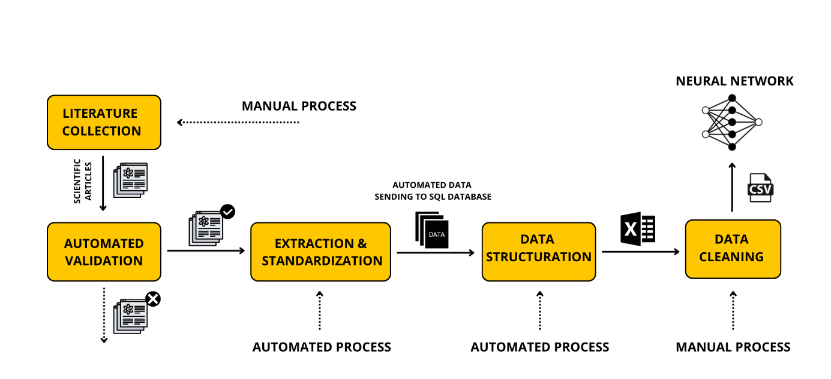
Figure 7: Workflow for dataset construction and predictive modeling

1.1 Software Environment and Workflow Orchestration
All stages of data collection, processing, and validation were performed using Langflow (v1.2.0), an open-source visual tool built for constructing flexible and modular AI workflows [7, 8]. The workflow was executed locally on a Linux workstation powered by an NVIDIA RTX 6000 Ada GPU, with the environment managed in a Python 3.11.11 virtual space. Development and troubleshooting were conducted using Visual Studio Code (version 1.96.2).
To guarantee full reproducibility, the entire installation process—including dependencies, environment setup, and Langflow configuration— are documented in both the official Langflow GitHub repository [15] and the project repository for this study [16]. Additionally, you’ll find everything you need: the complete setup details, all the source code, and the workflows (saved in JSON format) that we ran in Langflow, plus the articles we used for the dataset.
1.2 Database Structure
In this section, we outline the data framework developed during the initial phase of our research. The goal was to create a well-organized database, with each row representing an individual glass–test record and each column aligned to one of the 107 parameters extracted. The schema was carefully designed to encapsulate the full experimental context and facilitate cross-study comparisons.
The parameters were organized into four primary categories: general information, including bibliographic details (such as reference, author, and document type) and sample identifiers (e.g., glass name); glass composition, standardized into mol% of elements (e.g., Si, B, Na, O, Al), selected as the most chemically meaningful representation for cross-study analysis; experimental setup, encompassing sample properties (e.g., density, irradiation state) along with the experimental parameters (including factors like solution acidity, thermal conditions, exposed surface area, and solution volume); and the observed results, encompassing the initial rates at which Si, B, and Na dissolve, the degree of congruence, and the progression of pH throughout the experiment. A summary of the database structure, including column descriptions and sample entries, is presented in Figure 8, and a detailed list of all parameters and their definitions can be found in the project’s GitHub repository [16].
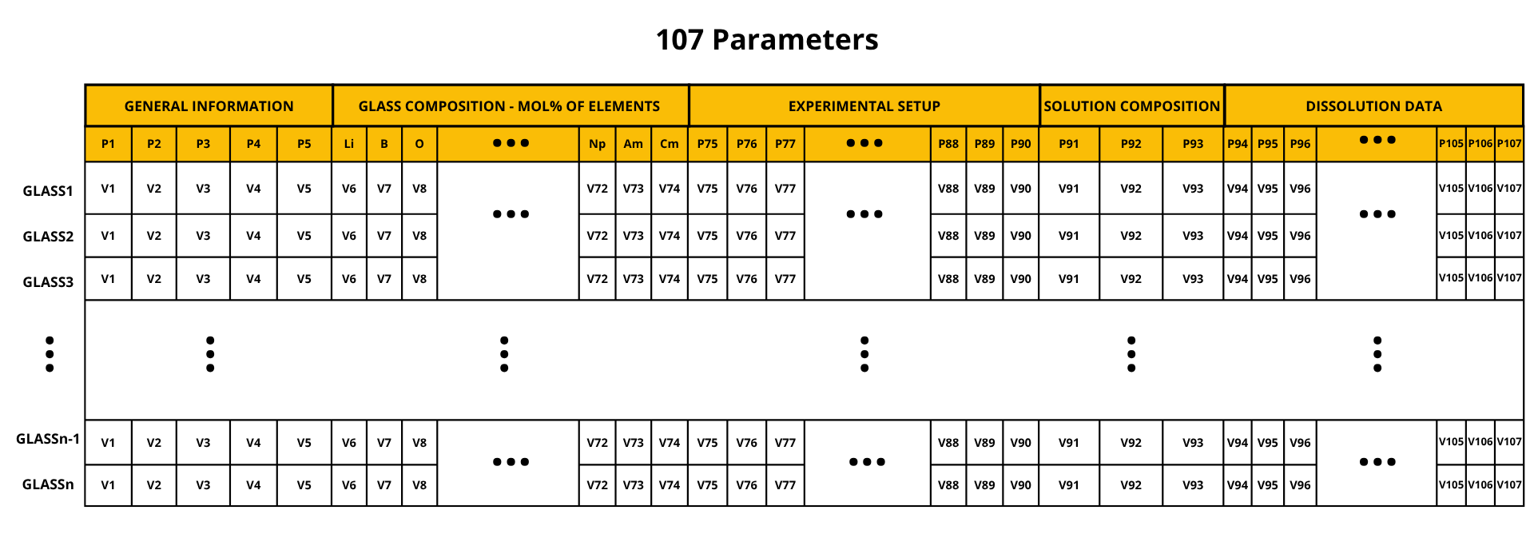
Figure 8: Database schema for structured glass dissolution data

2. Document Collection and Relevance Validation
2.1 Initial Collection of Scientific Literature
To build a dataset appropriate for AI-driven modeling of glass degradation processes, an extensive collection of potentially relevant literature was compiled. This involved manually searching academic databases and scientific engines using keywords focused on glass composition, early-stage dissolution kinetics, and long-term alteration patterns. The selection was further enriched by incorporating expert-recommended sources, some of which were only accessible as scanned documents. These required preprocessing through optical character recognition (OCR) to convert them into a format compatible with automated analysis.
Two distinct OCR approaches were assessed: Docling, an open-source tool recognized for its efficiency and ability to operate offline [17], and a local printer that has an OCR option optimized for maintaining the structural integrity of tables and technical figures. The combined use of these tools proved essential, as the quality of the original document significantly impacts OCR precision, especially for complex visual data [10]. This preprocessing phase was crucial to ensure that all selected articles could be seamlessly integrated into the subsequent automated validation process.
Given that critical parameters—such as full glass compositions and standardized dissolution rates—are seldom detailed in abstracts or titles, the relevance of each article could only be accurately assessed through a full-text review. To address this, a rigorous validation protocol was implemented to systematically evaluate the complete content of each publication against predefined inclusion criteria.
2.2 Automated Validation of Article Relevance
The automated validation process, illustrated in Figure 9, assessed each candidate publication by converting the entire document into unstructured text and applying a structured criteria sheet. This sheet, designed as a prompt, encoded all essential requirements for inclusion. It guided the large language model (LLM) in confirming whether the article included a fully specified glass composition (with a total near 100 mol%) and well-defined, standardized initial dissolution rates, and at least one relevant experimental variable—such as pH or temperature—directly linked to the dissolution data.
Crafting this prompt was essential because it clearly outlined what the LLM should assess, guided how the text should be understood, and defined the way the results should be presented. This approach guaranteed that the relevance assessment remained uniform, transparent, and repeatable across all documents. The use of domain-specific prompts aligns with cutting-edge methodologies in AI-assisted literature analysis and materials science research [7, 8, 9, 13].
We only moved forward with articles that fully matched our set criteria for the parameter extraction step. Any articles missing essential details were automatically left out to ensure consistency in our analysis. One constraint of this workflow is its focus solely on the main text of each article; if essential parameters are reported only in supplementary materials, those studies are automatically omitted. By setting these specific limits, we remove the need for manual checks, keeping the entire process automated and reliable every time.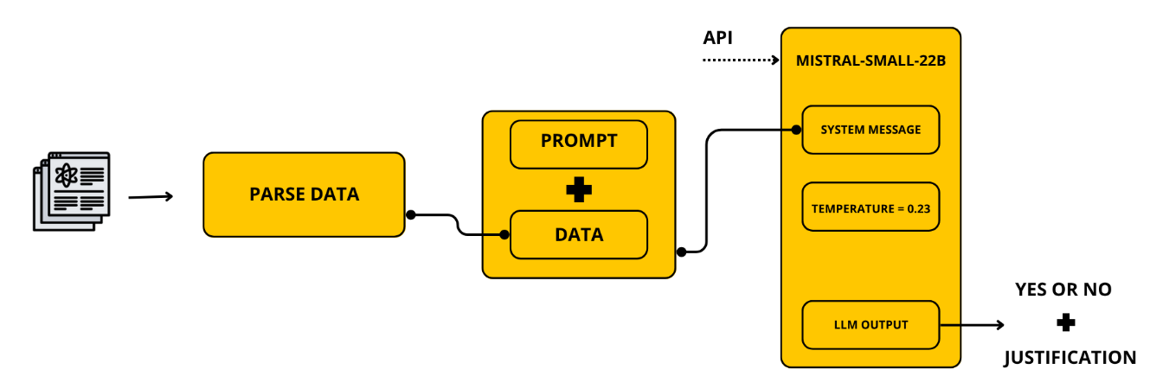
Figure 9: Schematic of the automated article validation workflow

3. Workflow Design for Automated Data Extraction
3.1 Motivation and Challenges
Once we confirmed the articles were relevant, our focus shifted to extracting all the essential experimental data—including glass compositions, test conditions, and initial dissolution rates—to build the structured dataset required for machine learning. Doing this manually would have been impossible given the sheer volume of data: some articles included over 30 different types of glass, each with up to 107 parameters to record.
Automating this process wasn’t straightforward. Many articles described multiple glass types, each tested under various conditions, which made the task even more complex. On top of that, the data formats varied widely—some studies reported compositions in weight percentages of oxides, while others used mole percentages of elements. Terminology also differed from one study to the next, with terms like V₀ and r₀, or S_geo and S_BET, being used interchangeably. Without a standardized interpretation, extraction would be fragile and error-prone.
To tackle these challenges, we developed a flexible, step-by-step system using Langflow. This workflow processes one article at a time, extracts the data in a standardized format, and automatically saves the results to an SQL database.

3.2 Overview of the Langflow Extraction Pipeline
To explain how the modular workflow operates, we introduce a symbolic unit referred to as Brain i (Figure 10). Each Brain i represents a specialized module designed for a specific task, such as identifying glass types, analyzing compositions, or extracting parameters. Each module relies on two main Langflow elements: a Prompt Template, which customizes the instructions for the specific task, and an LLM Node, which processes the prompt and corresponding document text using the language model (Mistral-small-22B).
To optimize context while staying within token constraints, the modules are also designed to accept additional structured data via the LLM Input channel.
To prevent token limits from being exceeded and to provide as much context as possible, each module can also receive organized supplementary data through the LLM Input channel. This setup allows for two separate input sources: the raw document content (fed as the system message) and structured data from earlier modules (passed as LLM input). The outputs are consistently formatted text responses. To ensure reliability and repeatable results, we set a fixed temperature of 0.23 across all modules. Unlike creative generation tasks, scientific data extraction requires consistent outputs with minimal hallucination risk; this low setting provides stability while maintaining flexibility in interpreting varied scientific phrasing [7, 8].
By chaining multiple brain blocks in series, the workflow achieves modularity, scalability, and explainability, with each stage performing a narrow task but contributing to the complete data extraction pipeline.

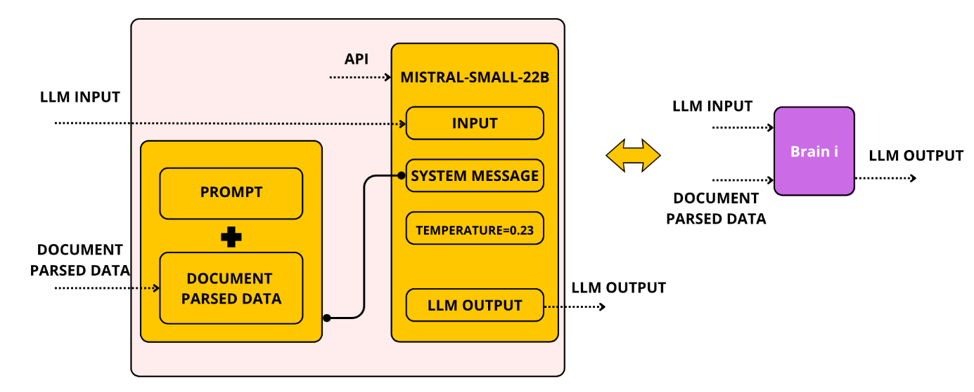
Figure 10: Internal structure of a Brain i module

3.3 Step-by-Step Pipeline Architecture
3.3.1 Glass Identification
The process (Figure 11) starts with the Parse Data component in Langflow, which breaks down the scientific article. The extracted information is then sent to Brain 1, whose job is to pinpoint every glass type mentioned in the article—but only those that include both a detailed composition and experimental results. The language model is given a clear, task-focused prompt along with the parsed text, and it responds with a numbered list of qualifying glasses. For instance, it might output something like: (1) Glass 1: NSAC19; (2) Glass 2: NSAC21.
Any glass that doesn’t meet these requirements is filtered out before moving on to the next step.
3.3.2 Composition Extraction (Glasses 1 & 2)
Given the constraints on token limits and the sheer volume of parameters involved, extracting all glass compositions in one go simply wasn’t practical. To work around this, the pipeline was designed as a series of smaller modules, with each one handling just two glasses at a time. Brain 3, for example, focuses on pulling out the detailed compositional data for the first two glasses. It does this by combining the parsed document with a carefully crafted prompt tailored to the task.
The language model is instructed to gather every available format of composition data—whether it’s reported as weight percent (wt%), mole percent (mol%), or in terms of oxides, elements, or cations—and to organize the results into a fixed six-field structure for each element. The expected output format looks like this:
Glass1:[oxide][element]:[value][wt%][oxide];[value][wt%][element];[value][wt%][cation];[value][mol%][oxide];
[value][mol%][element];[value][mol%][cation].
Glass2:[same format].
If any data is missing, those fields are filled with zeros. And if fewer than two glasses are identified, the empty slot is automatically populated with zero values to maintain consistency in the data structure.
3.3.3 Composition Normalization
The raw outputs are then sent to a dedicated Python script called "Convert Composition", which converts all the different formats into a unified representation: mole percentages of elements. Using molar masses and predefined oxide-to-element conversions, the script calculates standardized values for each component. The final output is straightforward and consistent, for example: Glass 1: 45 mol% Si, 30 mol% O, 12 mol% B, 13 mol% Na.
This normalization process was kept separate from the LLM pipeline because it requires precise stoichiometric calculations—something current language models struggle with. By handling it in Python, we ensure the data remains accurate and comparable across every glass sample.
3.3.4 Parameter Extraction (Glasses 1 & 2)
Once the compositions were standardized, Brain 4 took over to extract all remaining experimental parameters. The prompt included the exact parameter names, common synonyms (like V₀ and r₀), required units, and clear formatting guidelines (in this paper, we use the notation r₀, whereas the code implementation employs V₀).It also directed the model to identify how many tests were linked to each glass and to organize the results into lists of values. For instance, an article might produce output like: Temperature: [90, 100, 110]; Initial dissolution rate (Si): [1.2, 1.4, 1.1]; Initial pH: [6.5, 6.3, 6.8]. If a parameter wasn’t mentioned in the original article, it was explicitly marked as “Not available” to maintain the dataset’s completeness and reliability.
3.3.5 Processing Remaining Glasses
When this project was developed, Langflow didn’t yet support dynamic loops or iterative processing. To work around this limitation, we replicated the two-glass processing module up to 15 times, allowing us to handle the maximum number of glasses—30—found in any single article. While this approach made the workflow longer, it guaranteed that every glass was accounted for and kept the process consistent and repeatable.
3.3.6 Metadata Extraction
At the same time, Brain 2 gathered key metadata for each article, such as the document type, title, reference, lead author, and the total number of glasses identified. This information was saved in the database as source-level details, making it easier to filter articles, track citations, and perform broader analyses across the dataset.
3.3.7 Combining and Sending Data
Finally, a custom Python module combined all the glass-specific data and metadata into a single, cohesive dataset. The data was then transmitted to a SQL database, managed via a Flask API. To ensure seamless integration, the module demanded that all information be formatted as a strictly organized JSON file, matching the database’s schema. As long as the input adhered to this structure, the system would automatically process, categorize, and store the data in the database. For more details—including sample payloads and setup instructions—you can refer to the project’s open-source repository [18, 19].

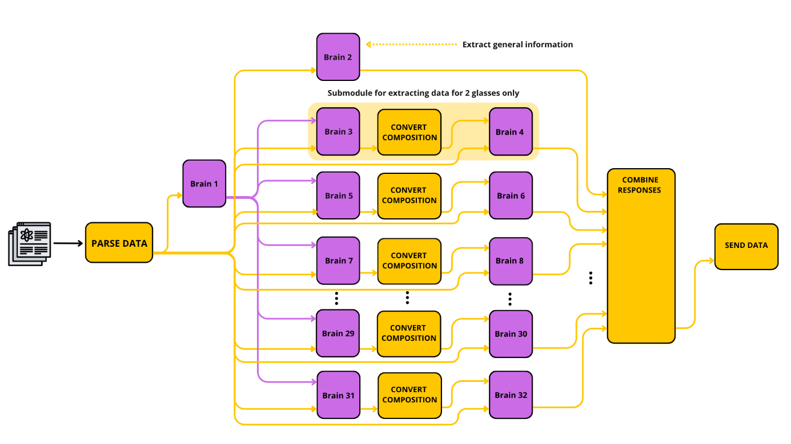
Figure 11: Scalable design of the Langflow-based extraction workflow
4. Database Schema and Flask Integration
To enhance the organization and handling of the extracted literature data, we created a custom SQL database and connected it to the Langflow pipeline using a Flask API. The whole system was isolated in its own Python virtual environment within VSCode, ensuring that database tasks remained completely separate from the Langflow workflow.
The Flask app had three key responsibilities: collecting the structured JSON output from Langflow, processing it, and filling in the predefined SQL database schema. In this schema, each parameter was assigned a specific column, with data stored row by row, where each row corresponded to a unique experimental test (e.g., a single glass sample under particular conditions).
To improve usability, we built a straightforward HTML interface linked to the database, enabling users to browse and inspect the stored data in real time. After processing all the articles, the complete dataset was ready to be exported to Excel, making it easy to move forward with tasks such as cleaning the data, selecting key features, and building predictive models.
The full source code, including the database schema, Flask server, and user interface, is publicly accessible in the project’s GitHub repository [18].
5. Model Training Setup and Objectives
5.1 Objective
The next phase of the process centered on developing a predictive model. The goal was to create a machine learning model that could forecast the initial dissolution rate (r₀) of glass based on its chemical composition and the specific testing conditions. Using the carefully prepared dataset, the model was designed to generalize its findings to new, unseen data, offering accurate predictions of dissolution behavior for novel glass formulations.
We approached this as a regression problem. The model took in data on the mole percentage of each element in the glass, as well as important experimental factors such as the initial pH level and the temperature during testing. Its output was a single predicted value for the dissolution rate (r₀), expressed in grams per square meter per day (g·m⁻²·d⁻¹). Since dissolution rates often vary across several orders of magnitude, the model was trained to predict the natural logarithm of r₀—ln(r₀)—instead of the raw value. This logarithmic transformation is a standard practice in studies of glass corrosion and kinetic modeling [3].
5.2 Dataset Preparation and Feature Selection
The original database included 107 parameters for each test, covering metadata, chemical compositions, and experimental conditions. A thorough cleaning and selection process was used to eliminate duplicate features and remove columns with too many missing values. Metadata unrelated to dissolution kinetics was also discarded. Based on expert insights [4,1], we determined three main predictor categories as the most impactful: (i) glass composition, expressed in mol% for elements such as Si, B, Na, Al, and Ca, Fe, Zr, and O; (ii) initial pH; and (iii) temperature. After this refinement, the dataset was reduced to 38 numerical predictors. Special care was taken with pH values, which varied across studies. We prioritized pH_initial (T essai) when available; if not, we used pH_initial (T amb) or pH_final, applying averaging when needed to ensure uniformity across the dataset. The finalized dataset was split into two parts: one for boron dissolution (370 entries) and one for silicon dissolution (230 entries). Each subset was divided into 80% training and 20% testing portions.
5.3 Model Architecture
The predictive model (figure 12) was built as a fully connected feedforward neural network (FFNN) using the TensorFlow/Keras framework. It featured an input layer with 38 neurons, followed by two hidden layers containing 64 and 32 neurons respectively, each with ReLU activations, and concluded with an output layer having a single neuron to produce a scalar regression output for ln(r₀).
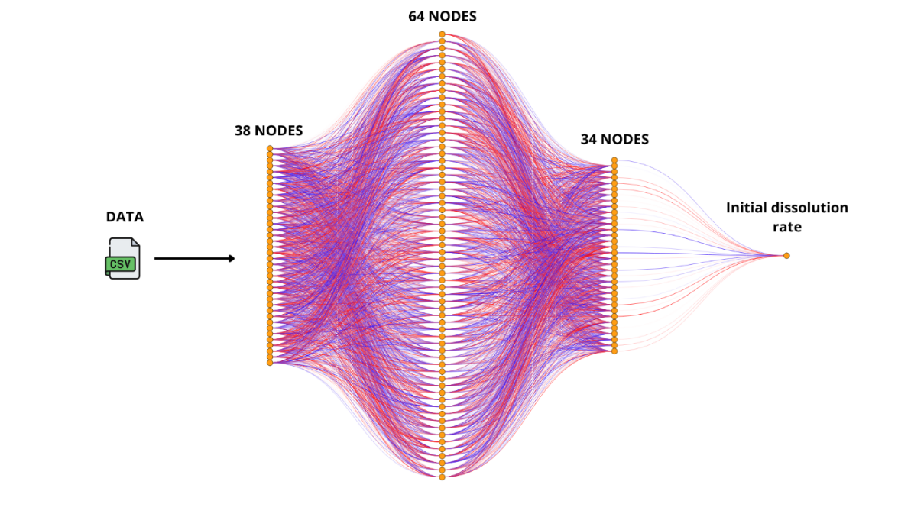
Figure 12: Architecture of the neural network for dissolution rate prediction

5.4 Training Setup
The neural network was trained with the Adam optimizer, using mean squared error (MSE) as the loss function. We employed a batch size of 16 and trained for up to 100 epochs, implementing early stopping based on validation performance to prevent overfitting. Input features were normalized using StandardScaler to achieve zero mean and unit variance. The training was performed on a workstation equipped with an Intel® Xeon® w9-3495X CPU and an NVIDIA RTX 6000 Ada GPU with 48 GB of memory.
5.5 Evaluation Metrics
The model's performance was evaluated on the test set using root mean squared error (RMSE), mean absolute error (MAE), and the coefficient of determination (R²). To evaluate bias and generalization quality, we used diagnostic visualizations, including residual plots, graphs comparing predicted values to actual ones, and training and validation loss curves.

Acknowledgment

This work was part of the CEA project VESTALE. It was carried out during a one-year internship of Abdelhak Ouanzougui at CEA under the supervision of Caroline Chabal.

Author contributions
A.O. (Abdelhak Ouanzougui) conceived the study, developed the extraction tools and all associated code, performed the analyses, and wrote the manuscript. C.C. (Caroline Chabal) supervised the work. S.G. (Stéphane Gin) and P.F. (Pierre Frugier) contributed to select the articles and supported interpretation of the results. F.L.F. (François Le Fèvre) contributed technical expertise, introduced the use of Langflow, provided guidance on generative AI tools. All contributed to the manuscript preparation.
Additional information
Data availability : The datasets generated and analyzed in this study are openly available in the NEURAL-NETWORK-TRAINING-ON-GLASS-ALTERATION-DATA repository at https://github.com/OUANZOUGUIAbdelhak/NEURAL-NETWORK-TRAINING-ON-GLASS-ALTERATION-DATA
Code availability : All source code, Langflow workflows (JSON format), and preprocessing scripts are available in the GLASS-GPT repository at https://github.com/OUANZOUGUIAbdelhak/GLASS-GPT

References
- Gin, S., et al. An international initiative on long-term behavior of high-level nuclear waste glass. Materials Today 16(6), 243–248 (2013). https://doi.org/10.1016/j.mattod.2013.06.008
- Ojovan, M. I. & Lee, W. E. An Introduction to Nuclear Waste Immobilisation (2nd ed.). Elsevier, Oxford (2014).
- Frugier, P., et al. SON68 nuclear glass dissolution kinetics: Current state of knowledge and basis for the new GRAAL model. Journal of Nuclear Materials 380(1–3), 8–21 (2008).
- Vienna, J. D., et al. Nuclear waste glass dissolution: Mechanism, model, and application. Journal of Non-Crystalline Solids 358(23), 2767–2782 (2013).
- Vienna, J. D., Ryan, J. V., Gin, S., & Inagaki, Y. Current understanding and remaining challenges in modeling long-term degradation of borosilicate nuclear waste glasses. International Journal of Applied Glass Science 4(4), 283–294 (2013).
- Cole, J. M., et al. The importance of data curation in scientific publishing. Patterns 2(6), 100286 (2020).
- Huang, B., et al. Extracting Accurate Materials Data from Research Papers with Conversational Language Models and Prompt Engineering. arXiv preprint arXiv:2401.00079 (2024).
- Kim, E., Huang, K., Saunders, A., McCallum, A., Ceder, G. & Olivetti, E. Materials synthesis insights from scientific literature via text extraction and machine learning. Chemistry of Materials 29(21), 9436–9444 (2017).
- Tshitoyan, V., et al. Unsupervised word embeddings capture latent knowledge from materials science literature. Nature 571, 95–98 (2019).
- Petti, C. M., et al. Challenges in digitizing and extracting materials data from literature. J. Chem. Inf. Model. 62(6), 1392–1404 (2022).
- Pieraggi, B., et al. The effect of pH, temperature and surface area on the dissolution rate of nuclear waste glasses in unsaturated conditions. J. Nucl. Mater. 298(1–2), 26–36 (2001). https://doi.org/10.1016/S0022-3115(01)00618-4
- Abdelouas, A., et al. The mechanism of alteration of nuclear waste glass in unsaturated conditions. J. Nucl. Mater. 211(2), 143–156 (1994).
- Ward, L., et al. A general-purpose machine learning framework for predicting properties of inorganic materials. npj Comput. Mater. 4, 36 (2018). https://doi.org/10.1038/s41524-018-0088-8
- Jha, D., et al. ElemNet: Deep learning the chemistry of materials from only elemental composition. Sci. Rep. 8, 17593 (2018).
- Langflow. Langflow: Open-source visual framework for building LLM applications. GitHub repository (2025). https://github.com/langflow-ai/langflow
- Ouanzougui, A. GLASS-GPT: Automated extraction pipeline for glass dissolution data. GitHub repository (2025). https://github.com/OUANZOUGUIAbdelhak/GLASS-GPT
- Docling. Docling: An open-source OCR and document parsing toolkit. GitHub repository (2024). Available at: https://github.com/DS4SD/docling
- Ouanzougui, A. FLASK-APPLICATION: Flask pipeline for glass dissolution data. GitHub repository (2025). https://github.com/OUANZOUGUIAbdelhak/FLASK-APPLICATION
- Ouanzougui, A. NEURAL-NETWORK-TRAINING-ON-GLASS-ALTERATION-DATA :Neural networks and data. GitHub repository (2025). https://github.com/OUANZOUGUIAbdelhak/NEURAL-NETWORK-TRAINING-ON-GLASS-ALTERATION-DATA

